Table S1. Class-wise performance of the Random Forest classifier on the dermatology dataset.
Disease Class | Precision | Recall | F1-score | Support
Psoriasis | 1.000 | 1.000 | 1.000 | 23
Seborrheic Dermatitis | 0.909 | 0.833 | 0.870 | 12
Lichen Planus | 1.000 | 1.000 | 1.000 | 15
Pityriasis Rosea | 0.818 | 0.900 | 0.857 | 10
Chronic Dermatitis | 1.000 | 1.000 | 1.000 | 10
Pityriasis Rubra Pilaris | 1.000 | 1.000 | 1.000 | 4
Weighted Average | 0.961 | 0.959 | 0.959 | 74

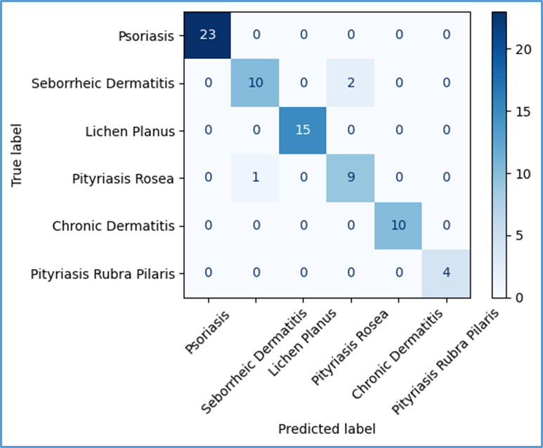
Supplementary Figure S1. Confusion matrix of the Random Forest classifier evaluated on the dermatology test dataset.

Table S2. Class-wise precision, recall, F1-score, and support obtained using the Support Vector Machine (SVM) classifier on the dermatology test dataset.
Disease Class | Precision | Recall | F1-score | Support
Psoriasis | 1.000 | 1.000 | 1.000 | 23
Seborrheic Dermatitis | 1.000 | 0.833 | 0.909 | 12
Lichen Planus | 1.000 | 1.000 | 1.000 | 15
Pityriasis Rosea | 0.833 | 1.000 | 0.909 | 10
Chronic Dermatitis | 1.000 | 1.000 | 1.000 | 10
Pityriasis Rubra Pilaris | 1.000 | 1.000 | 1.000 | 4
Weighted Average | 0.977 | 0.973 | 0.973 | 74

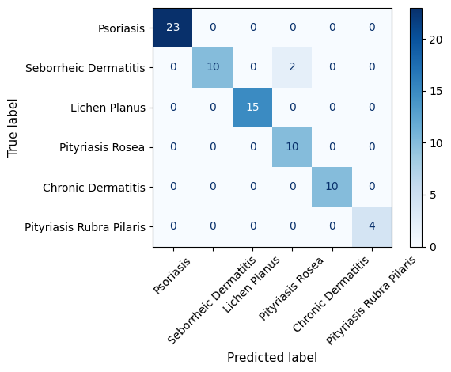
Supplementary Figure S2. Confusion matrix of the Support Vector Machine (SVM) classifier evaluated on the dermatology test dataset. The confusion matrix summarizes the classification performance across the six dermatological disease classes.
Table S3. Class-wise precision, recall, F1-score, and support obtained using the XGBoost classifier on the dermatology test dataset.
Disease Class | Precision | Recall | F1-score | Support
Psoriasis | 1.000 | 1.000 | 1.000 | 23
Seborrheic Dermatitis | 0.900 | 0.750 | 0.818 | 12
Lichen Planus | 1.000 | 0.933 | 0.966 | 15
Pityriasis Rosea | 0.750 | 0.900 | 0.818 | 10
Chronic Dermatitis | 0.909 | 1.000 | 0.952 | 10
Pityriasis Rubra Pilaris | 1.000 | 1.000 | 1.000 | 4
Weighted Average | 0.938 | 0.932 | 0.933 | 74

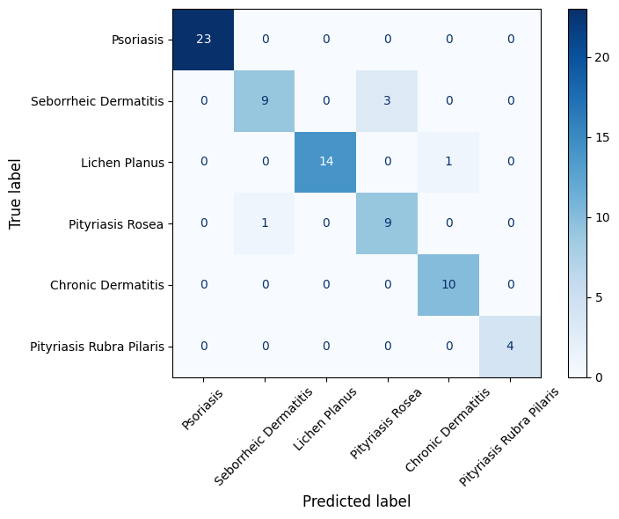

Supplementary Figure S3. Confusion matrix of the XGBoost classifier evaluated on the dermatology test dataset. The confusion matrix summarizes the classification performance across the six dermatological disease classes.

